Technologies used

1. [Java NetBeans // To Download the NetBeans file click (ctrl+Enter) on the blue word .onstall only the NetBeans from above link to](https://drive.google.com/drive/folders/13OjYSFFDwkv9glP3cd6jVLxfr8N1pltC?usp=sharing)
2. [Xampp](https://drive.google.com/file/d/1LbpaX3XwhCFhHGF8OJL8LuWsnbwrXbMp/view?usp=sharing) // To Download the Xampp file click (ctrl+Enter) on the blue word
3. [Mysql Database](https://drive.google.com/file/d/1deJmFnyJUc3X6d416K3asmj46l9cGDeI/view?usp=sharing) // To Download the database file click (ctrl+Enter) on the blue word

Instruction to Use the project

* TO install and use the project you need to be download above mentioned software’s to use the project.

https://drive.google.com/drive/folders/13OjYSFFDwkv9glP3cd6jVLxfr8N1pltC?usp=sharing

<https://drive.google.com/file/d/1LbpaX3XwhCFhHGF8OJL8LuWsnbwrXbMp/view?usp=sharing>

https://drive.google.com/file/d/1deJmFnyJUc3X6d416K3asmj46l9cGDeI/view?usp=sharing

* After installing above mentioned software’s then you need to run the NetBeans and import the project from location where you have installed.
* To import the project here are dome instruction
  + Open NetBeans
  + Click File >Open project
  + Navigate the location of project where you have installed
  + Then click open project
  + Then clean and build the project.
* Then import the database file with extension “.sql” in myphp admin
  + Install Xampp
  + Open the Xampp and start the mysql and apache then click the mysql admin

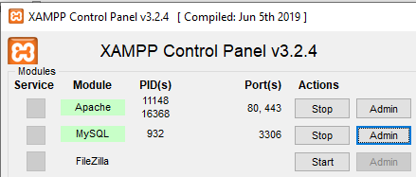

* + After that local host will open in default browser then you need click import

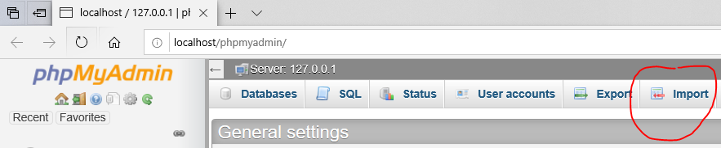

* + Then click the browse and navigate the location of “DB.sql” you have installed or you can find it in project file that you have downloaded or download from above given third link.
  + Then Click the go in the last of the page

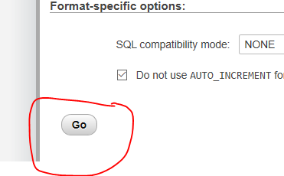

* After that in NetBeans you have to connect with Xampp

<https://youtu.be/Lq8V-pD4qCo>

By clicking above link there is the video how to connect NetBeans with Xampp by watching this you can connect with server. And enjoy the service.